Megan Leonard

6/20/2021

COMP 201 Homework 5

Answer the following questions based on your reading of the textbook, the module study notes, the videos, and the instructor’s presentation this week.

1. (Englander, exercise 10.1) Explain why it is easy to perform read and write in place on a disk but not on a tape.

A disk can be ran continuously, while a tape has to start and stop. The disk can be reversed and rewound easier than a tape as a tape would take more time doing these tasks. To get to the point that the read is to be performed, a disk can easily move to the point while the tape has to be moved to the desired point.

1. (Englander, exercise 10.3) A multiplattered hard disk is divided into 1100 sectors and 40,000 cylinders. There are six platter surfaces. Each block holds 512 bytes.

The disk is rotating at a rate of 4800 rpm. The disk has an average seek time of 12 msec.

1. What is the total capacity of this disk?

6 tracks times 1100 sectors times 40000 cylinders times 512 bytes is equal to 135.168 Gigabytes or 135136000000 bytes for the total capacity.

1. What is the disk transfer rate in bytes per second?

6 tracks times 1100 sectors times 512 bytes times 4800rpm all divided by 60 seconds = 270336000 bytes per second.

1. What are the minimum and maximum latency times for this disk? What is the average latency time for this disk?

The minimum would be 0 while the maximum latency would be 60 times 1000 divided by 4800rpm to get 12.5. The average latency time is then 0.5 times 60 divided by 4800 to give 0.00625sec.

1. (Englander, exercise 10.4) The average latency on a disk with 2200 sectors is found experimentally to be 110 msec.
2. What is the rotating speed of the disk?

Rotating speed for the disk is 1 divided by 2 times 100msec making it 0.00454.

1. What is the transfer time for one sector?

The transfer time is 1 divided by the .00454 rotating speed times the 2200 sectors to get 0.1001.

1. (Englander, exercise 10.10) A high-quality photographic image requires 3 bytes per pixel to produce sixteen million shades of color.
2. How large a video memory is required to store a 640 × 480 image during display? A 1600 × 900 image? A 1440 × 1080 image?

640 × 480 image = 640*480*3 = 921600 bytes

1600 × 900 image = 1600*900*3 = 4320000 bytes

1440 × 1080 image = 1440*1080*3 = 4665600 bytes

1. How many 1024 × 768 non-compressed color images will fit on 4.7 GB DVD-ROM?

1024 x 768 image = 1024*768*3 = 2359296 bytes then 4.7GB =  4812.8MB, 4928307.2KB, then 5046587000bytes

then we take 5046587000/2359296 = 2139 non-compressed color images.

1. (Englander, exercise 11.2) [**Figure 11.8**](http://0-proquest.safaribooksonline.com.olinkserver.franklin.edu/9780471715429/putting_all_the_pieces_together#general_bus_interface_configuration_for) shows that a typical computer system is interconnected with a number of different buses, both internal and external. The diagram includes multiple cache buses, an external CPU bus, PCI-Express buses, a parallel PCI bus, SATA buses, USB ports, and more. What are the advantages of providing multiple buses rather than connecting everything together with a single bus?

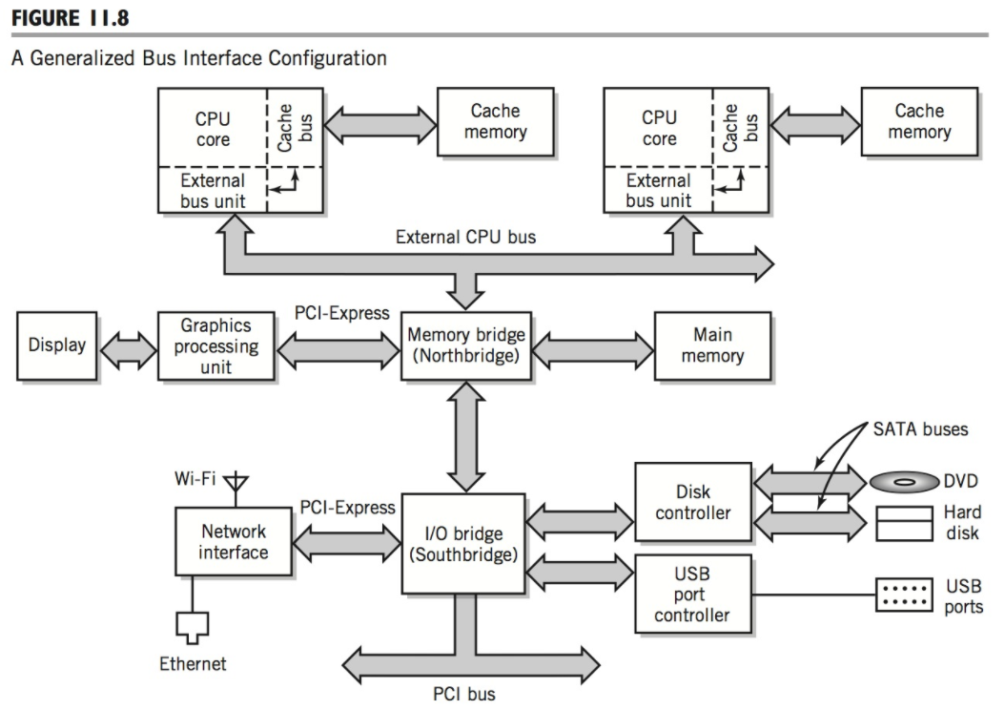

By using multiple buses, the system can run better with performance. A single bus has several different jobs that it maintains for the interface. By using multiple buses each bus can do a single job so the network can run faster and more efficiently.

1. (Englander, exercise 11.9) Discuss the major differences, advantages, and disadvantages between bus I/O and channel I/O.

The bus I/O is the main used form of I/O and makes a communication link that connects the I/O to the memory and the processor. The channel I/O can act as its own computer solely for the I/O and has a main subsystem that connects the paths. The bus I/O has the advantages of lower cost, can attach multiple devices with ease, and can add more buses to the interface. The disadvantages is that it has a limited bandwidth and band speed based on the buses it has. The channel I/O had the advantages of faster and wider band speed and bandwidth. Data transfers at a faster rate and with more at a time. The disadvantages are that it is more expensive compared to bus I/O and the mechanisms need to be in synch for the data to transfer correctly.

1. (Englander, exercise 11.15) How does a Beowulf cluster differ from other types of clusters?

A Beowulf cluster is a cluster of computers that act as a single machine while other types of clusters act more as a workstation. Each node has access to a monitor and keyboard through the Beowulf cluster.

1. (Englander, exercise 12.1) Discuss the trade-offs between circuit switching, packet switching, and virtual circuit switching.

Do not need to do chapter 12.

1. (Englander, exercise 12.6) Suppose that you are trying to design a network that would be suitable for a company that is located in several buildings scattered around a town. No building is more than a 1/4 mile from another building, but direct wire connections between all buildings are not possible due to roads, houses, and other obstacles. Propose a network configuration for this company, and justify your proposal.

Do not need to do chapter 12.

1. Explain the relationship between corresponding layers at the source and destination nodes of a TCP/IP communication connection.

Do not need to do chapter 12.

1. In two to three paragraphs of prose (i.e. sentences, not bullet lists, and 350+ words) using APA style citations if needed, summarize, and interact with the content that was covered this week in class. In your summary, you should highlight the major topics, theories, practices, and knowledge that were covered. Your summary should also interact with the material through personal observations, reflections, and applications to the field of study. In particular, highlight what surprised, enlightened, or otherwise engaged you. Make sure to include at least one thing that you’re still confused about. In other words, you should think and write critically not just about what was presented but also what you have learned through the session. Feel free to ask questions in this as well since it will be returned to you with answers.

This week we looked at the tenth and eleventh chapters. The tenth chapter goes through different computer parts like the storage and memory. It then moves to disks and displays. A lot of the topics I found I could relate to my other classes. After taking my exam for another class I saw that some of the topics appeared here as well as that exam. Having taken some other classes prior to this I think a lot of the topics relate to the ones I have gone over in the past. The eleventh chapter covered the computer systems where it had the system architecture and the performance computing. I remember the bus and the different types that go along with them. The Beowulf cluster was new to me and interesting to read about. I can see how it stands out compared to the other clusters.